Sevent — Infrastructure and Deploy Flow
Sevent is a Next.js application self-hosted on a single cloud VPS alongside a full Supabase stack. All public traffic enters through a Cloudflare tunnel; no ports are exposed on the host.

Runtime architecture
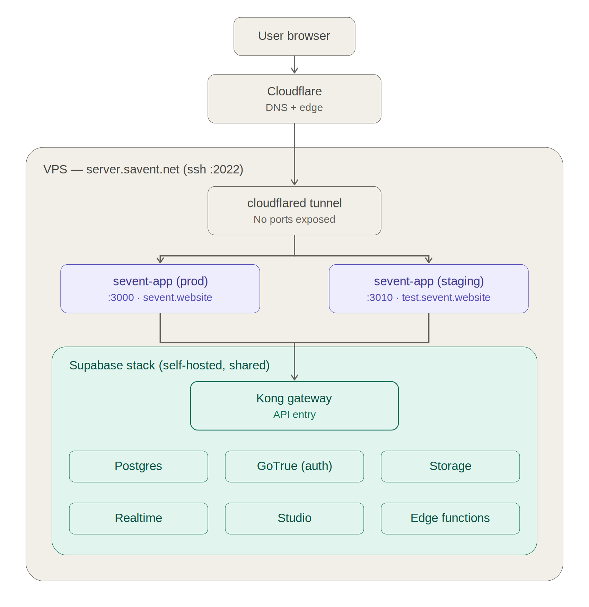
Production (:3000 → sevent.website) and staging (:3010 → test.sevent.website) run as separate containers on the same VPS, sharing one Supabase backend behind the Kong gateway.

Deploy SOP
Every deploy follows the same sequence. Staging is always validated first; promotion to production only happens after explicit user approval at test.sevent.website.
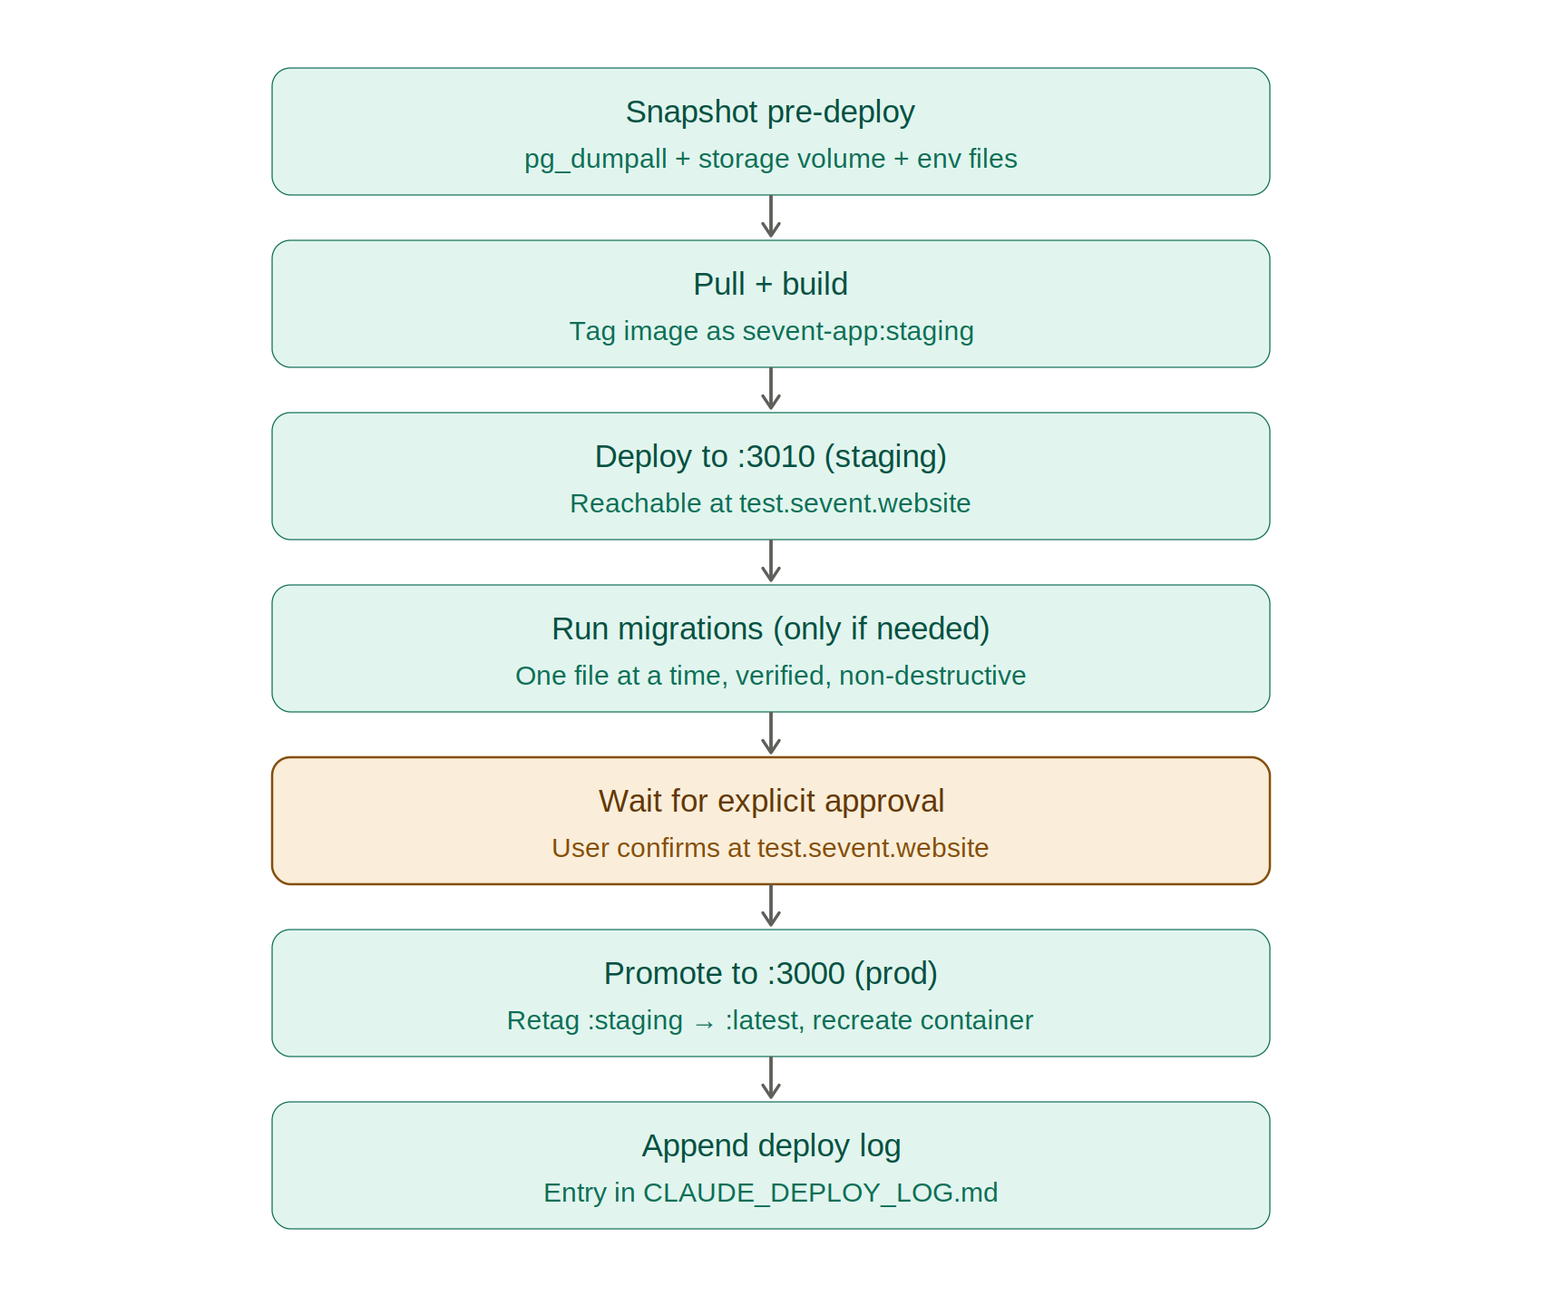
Snapshots are kept under /var/backups/sevent/deploys/ (last 10 deploys + 30 daily). Every staging or production event is appended to CLAUDE_DEPLOY_LOG.md.

